**ER Diagram**

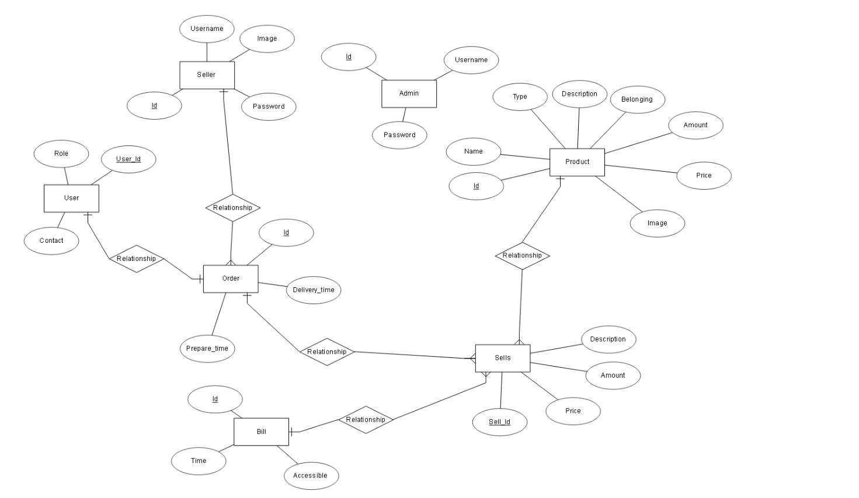

**Relational Schema**

Time when user (customer) confirm the order

Determine if product belong to the Mensa part or Cantina part.

Most of Cantina products don’t have description because they are not prepared in Cantina

Can be ingredients or other information about preparation

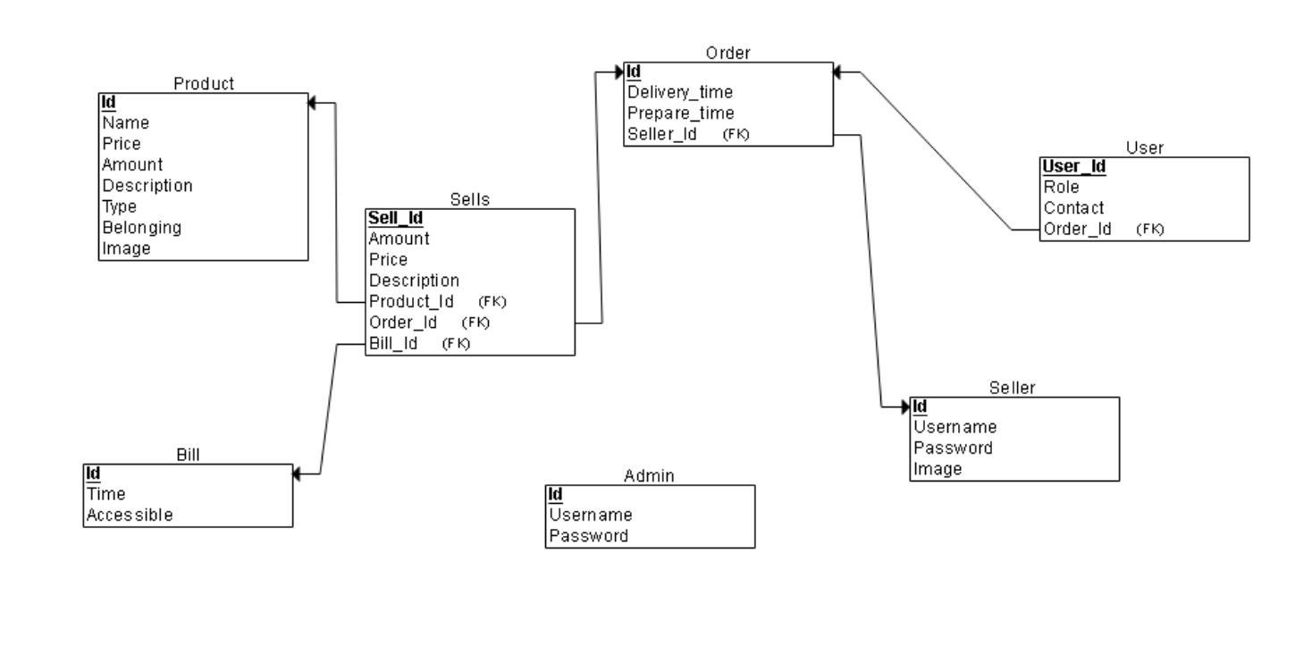

Time after purchase is done

Can be true or false

So as long as the bill is present in current turn seller that is responsible for that bill ca access otherwise no.

Role serves to determine if is student, professor or visitor.

Professors (receive free)

Type can be: cold drinks, hot drinks, deserts, fast food, soups, salads etc.

Time when seller confirm that order is ready

User preferences for prepared products

Price is like total 🡪

Amount * Product price